Biographical notes for
ROY JAY DUTCHER

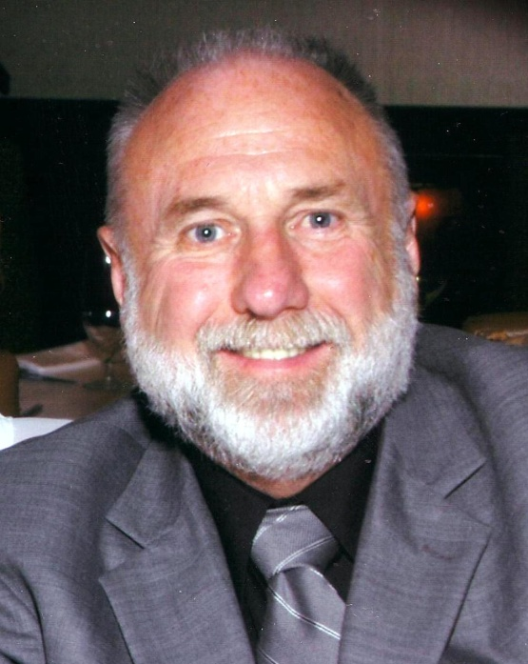
Roy Dutcher is Vice President and Director of Training for TMC Group US, Inc. Consultant/ Trainer for NFPA 70E.

Mr. Dutcher is a Master Electrician with over 40 years of electrical experience and over 15 years experience training and consulting on NFPA 70E.

Roy has a real passion for NFPA 70E and it is evident by his 99+% satisfaction rating. He has provided training and consulting all across the United States and Canada for diverse customers like the United States Armed forces, Auto Manufacturers, Major Casinos, and many fortune 500 companies.

Roy’s electrical career started sometime before 1966. He served as a Radar Technician with the United Stated Army from 1966 to 1970. He later completed a four year apprentice program. He worked in the trade from 1970 to 1982 as an Apprentice, Journeyman, Foreman, Area Foreman, General Foreman, Construction Manager, and Vice President for various electrical contractors.

In 1982 Roy started doing electrical contracting on his own. His company successfully completed thousands of projects from residential to commercial and industrial work including networking, telephone systems, alarm systems, and other technologies.

Roy started teaching apprenticeship training in 1990. He discovered he has a real passion for training and enjoys helping people learn. He started doing NFPA 70E training in 1998. In 1999 he is qualified as an expert witness in Federal OSHA Court. In 2000 Roy started offering his training Nationwide.

Roy has many true stories to share. He has conducted interviews with medical experts and victims. Videos of these interviews and the stories in his multimedia presentation make clear the dangers of not working safe. He is able to make this difficult subject understandable with humor, high energy and real-world stories, the information is presented in a way your employees will respond to and remember.

