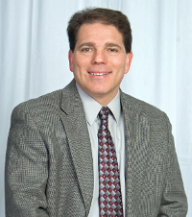Marty Schumacher worked as a Howard County electrical inspector for 17 years and currently is a Howard County Electrical Plans Examiner. He holds a Maryland master electricians license, Journeyman’s license, and is a member of the NFPA, IAEI, AFAA and is an ICC certified commercial electrical inspector, residential inspector and electrical plans examiner as well as the International Association of Electrical Inspectors (IAEI) Master Certified Electrical Inspector (CEI-M). Marty has taken numerous electrical courses and seminars since 1983, and is devoted to a lifetime of learning. As a trained electrician and former electrical contractor, Marty brings his lifetime of learning and nearly 19 years as a code instructor into all of his classes. His high energy, dynamic approach and years of developing unique techniques and developing skills as an expert speaker, will help you in all of your electrical code training needs. His background as a former musician, Sunday school teacher, master of ceremonies, and many more public speaking opportunities, has uniquely prepared him for teaching.

In July of 2009, Marty won the "Top Gun Instructor" award in Orlando, Florida at the Mike Holt, "Train the Trainer seminar." Twenty Eight instructors from all over the country chose Marty as the "Top Gun", and Mike Holt awarded him this distinct honor.
Marty is active on numerous electrical boards and committees nationally as well as the state of Maryland and is committed to giving back to the industry that he loves.
A lifelong Marylander, Marty lives in Westminster with his wife Trish, and their 3 children.
"As for me and my house, we will serve the Lord"

