Dangers of Stray Voltage and Stray Current

Material is copyrighted
Donald W. Zipse, P.E.
PO Box 7052
Wilmington DE 19803-0072

The Problem
A person normally thinks of electricity as being contained in two wires. An example is the common electric light fixture found in homes, where the cord attaching the light fixture to the electrical receptacle in the wall has two conductors. Many plugs that plug into the wall receptacle have only two metallic prongs, one for each wire. One wire is usually black or referred to as being hot or a phase conductor. The other wire is usually white and is called the neutral.

For safety purposes the National Fire Protection Association’s (NFPA) National Electrical Code (NEC) required in residential, commercial and industrial facilities, starting in approximately 1950 a third wire, the equipment grounding conductor. This wire was added to electrical appliances such as electric drills, heaters, washing machines, etc. This third wire has either a green color insulation over the conductor or the conductor is bare and is contained within a cord with an outer jacket. This conductor is called the equipment-grounding conductor and is connected to the neutral at just one point within the house, at the service entrance and this equipment-grounding conductor is connected to earth. The green color or bare conductor can be connected both intentionally and unintentionally to earth at many places.

The function of the equipment-grounding conductor, the green or bare conductor is not to carry any continuous flowing electric current. The key word here is “continuous.” The only time the equipment grounding conductor carries any electric current is when an electrical fault occurs and then the object of the equipment grounding conductor is fulfilled by allowing the fault current to flow back to the source without any or with very little resistance or impedance. This allows the protective device, such as a fuse or circuit breaker to operate and turn off the electricity thus ending the hazardous electrical fault condition.

For over 50 years, the 3-wire concept has been used to insure electrical safety in 600 volts and below electrical circuits, which are used in homes, commercial and industrial establishments:
- Phase Conductor carrying electric current to the load or appliance
- Neutral conductor carrying all the return electric current
- In addition, the equipment grounding conductor only carrying electric current when an electric fault occurs to insure adequate flow of electric fault current to operate the protective device such as to blow the fuse or open the circuit breaker.
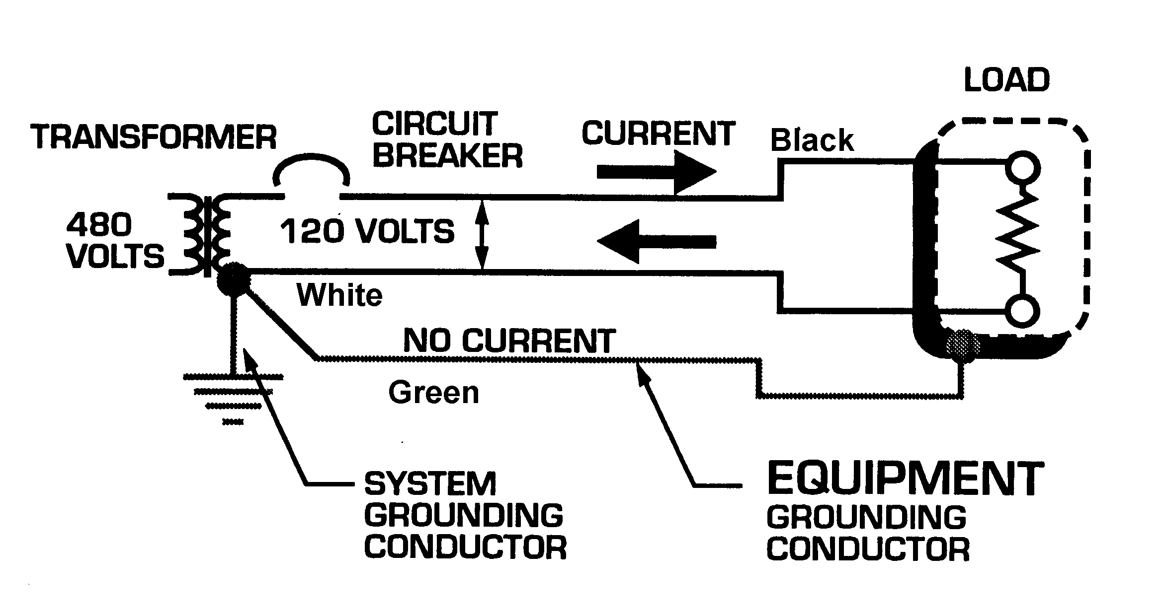
Figure 1. Circuit diagram showing the black phase conductor carrying current, the white neutral conductor carrying return current and the equipment grounding conductor carrying no continuous current.

This concept of restricting electrical current flow over the equipment grounding conductor to only momentary fault current is valid for all electric circuits of any voltage when safety is a major concern. This is true whether low voltage or high voltage, whether electrical house wiring or electrical distribution wiring.

The majority of the electrical utilities have elected to sacrifice electrical safety of personnel and animals in order to save costs of electrical distribution installations by combining two conductor functions into one conductor. The savings in costs equate to function of the additional profits to the . . .

. . . Corporation and other utilities and showed their indifference and insensitive to the safety of humans and animals.

The utilities saving are made by the installation of:

- one less electrical distribution conductor,

- purchasing of transformers with less electrical installation,

- purchasing transformers with only one high voltage bushing instead of two,

- decreased number of pole insulators and/or cross arms that would be required,

- reduced installed labor costs,

- eliminating many other minor items that increase the utilities savings.
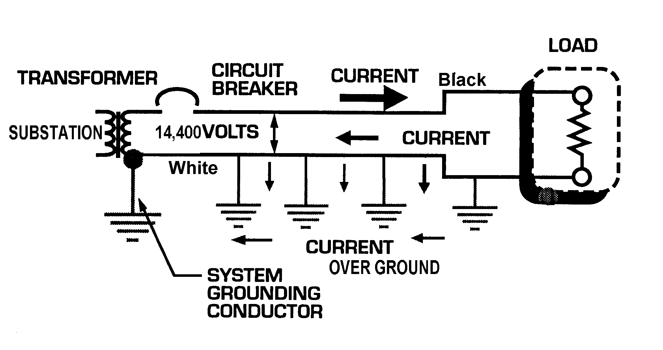
Figure 2. Diagram showing the electrical substation with a transformer, protective device, the circuit breaker, the two electrical distribution conductors, the multiple connections of the neutral to earth and the flow of uncontrolled electric current over the earth.

The problem is that the utilities and in particular . . . Corporation have used the earth as a partial return for the neutral current allowing the neutral current to continuously flow uncontrolled over the earth, which has caused irreparable and irreversible harm to . . . .

Is It “Stray Voltage” or “Stray Current”?
Before one can fully comprehend the magnitude of the cow problem and electricity one has to understand the difference between “Stray voltage” and “Stray Current”. When voltage is measured, the measurement is between two points. If we think about a pipe with water under pressure, all we have to do to measure the water pressure is to insert a pressure gauge into the pipeline. The water gauge appears to have only one point of contact, however the atmospheric pressure is pressing down on the pressure gauge. Thus, we are measuring the difference between the pressure inside the pipe and the pressure outside the pipe. The pressure is being measured is across two points.

When we use a voltmeter to measure electric pressure, we are measuring the voltage across two points. Remembering Ohm’s Law which states in order to have a voltage we must have a current flowing through a resistance; Voltage = Current times Resistance. The voltmeter contains a very, very large resistance that allows an infinitesimal amount of current to flow so that for routine purposes one can state that there is insufficient amount of current flowing through the voltmeter and thus ignore this infinitesimal amount of current. This is true especially with a solid-state voltmeter.

Thus, it is very easy to measure voltage as compared to measuring current. In order to measure current one method is to place a sensing coil around the conductor. Ammeters are made with a split coil that opens to allow a conductor to be placed within the center of the sensing coil.

The largest opening for a standard available ammeter coil is 12 inches. One could place the sensing coil around a cow’s leg if the cow permitted it. However, the cow has four (4) legs. Even though it appears simple to measure current in a conductor it is difficult but not impossible to measure current flowing through a cow. All one has to do is to divide the area that a cow stands on into four quadrants, insulate the four quadrants from each other and measure the current flowing into the four (4) quadrants.

The question that begs an answer is which is the determining factor, voltage or current. In order to answer that question we need to look at the human animal sensitivity to voltage and current.

Human Animal Sensitivity to Electricity

It has been reported that Professor Charles F. Dalziel, University of California “required” his students to participate in experiments to measure the human animal’s response to voltage and current by placing their feet into a bucket of salt water and holding onto a conductor. Professor Dalziel then applied varying amounts of current and measured their response. Professor William B. Kouwenhoven, Electrical Engineering, John
Hopkins University used fresh cadavers to measure electric current necessary to revive the heart in order to develop the defibrillator. These experiments along with Prof. Charles F. Dalziel, produced Table 1,

It has been shown that it takes approximately 35 volts across dead, dry skin to force electricity into the human body. Less voltage or electrical pressure is required for a women’s dead, dry skin.
 | Direct Current |  | Alternating |  | Current
 |  |  | 60 Hz |  | 10 kHz
 | Men | Women | Men | Women | Men | Women
Slight sensation
on hand | 1 | 0.6 | 0.4 | 0.3 | 7 | 5
Perception "let go"
threshold, median | 6.2 | 3.5 | 1.1 | 0.7 | 12 | 8
Shock - not painful and no
loss of muscular control | 9 | 6 | 1.8 | 1.2 | 17 | 11
Painful shock - muscular
control lost b 1/2% | 62 | 41 | 9 | 6 | 55 | 37
Painful shock - "let-go"
threshold, median | 76 | 51 | 16 | 10.5 | 75 | 50
Painful and severe shock -
Breathing difficult,
muscular control lost | 90 | 60 | 23 | 15 | 94 | 63

Table 1. Sensitivity of Humans to Electric Current in Milliamperes

Appendix shows the values of resistance for the human body.

Corporation elected to use an unsafe electrical distribution method. It will be shown that earth return had been tried in the early days of electrical distribution and found hazardous and harmful to not only the human population but to animals too.

Experience of Thomas A. Edison and Earth Return of Electrical Current

The first electrical distribution system was patented by Thomas Alvin Edison. The patent was filed on February 5, 1880 in the United States and given the number 2,282. It was titled, “System of Electrical Distribution”.

Edison tried several approaches to distributing electricity. Tom Shaughnessy, PowerCET Corporation writes, “Early on, Edison implemented a floating approach for his DC systems after several events demonstrated the adverse effects of stray DC currents flowing throughout buildings and neighborhoods. Once, a horse was shocked when it walked on "electrified soil" near Edison's Pearl Street generating station and laborers working on his underground
distribution system believed there was a "devil in the wire."‘ As a result of some of these problems, Edison apparently adopted a three wire system which did not rely upon earth return.” [5]

With five years of experience, Edison in August 30, 1887 in his Specifications forming part of Letters Patent No. 369,280 on page 2, line 34, states:

“All of such conductors from the generators at the station to the lamps are made in pairs--one for the outgoing current and the other for the returning current of electricity, the circuits throughout the system being complete or

Figure 4. Direct Current Electrical System Earth Used as Current Return Path

round metallic circuits, the conductors of which are well insulated from each other and from the earth. (Emphases by the Author) The use of the earth for one half of the circuit would largely increase the difficulties arising from the grounding of the conductors or the crossing of the conductors among themselves or with the conductors of other circuits to such an extent that a system so constructed would be impracticable.”

Edison recognized the hazards involved in using the earth as a return path. “The Edison Three-wire System” is described in the Instruction book No. 8148, published by the General Electric Company in Dec. 19, 1900 and consists of a three wire grounded mid-point at one location only, which supplies phase to phase voltage of 220 and 110 volts for lightning. This is the basis of the electrical distribution in homes today.

Figure 5. 3-Wire Direct Current Electrical System Conductor Used as Current Return Path

With a balanced electrical load, that is loads “A” equal to loads “B” the current in the neutral will cancel and the neutral will not carry any current. The maximum amount of current the neutral will carry will be if the load is connected to, one generator only, and only that load, is turned on.

The statement, “As the electrical load increases the detrimental effects, also increase” is verified in the reference [K] where persons received electric shocks in the swimming pool, which is an equal potential plane, on days the temperature was above 95 ºF and in the early evening when the owners returned and turned on the air conditioners, electric ranges and microwave ovens, etc.

Instead of lowering the lightning arrester’s resistance to earth by installing additional ground rods, at an additional costs to the utilities and in particular to . . . Corporation, the utilities and in particular . . . Corporation elected to save the additional costs by using the customers’ connections to earth. This practice placed the homeowners and the farmers in danger from excessive lightning current flow and the potential of high voltages during the lightning arresters’ operations. The savings in costs equate to additional profits to the . . . Corporation and other utilities and showed their indifference and insensitive to the safety of humans and animals.

This connection permitted the hazardous electrical current from the operation of the lightning arrester to flow into the customers’ homes, into the homeowner’s ground rod, through the metallic water piping without their knowledge or consent which benefited the utility without proper approval or compensation of the owner of the secondary wiring system.

Primary Neutral to Secondary Neutral Connection

The extension of this invasion of the customers’ wiring systems was when the utilities flagrantly, egregiously connected the primary neutral to the secondary neutral at the transformer and allowed primary neutral current to flow unimpeded into and over the customers’ homes, into the homeowner’s ground rod, through the metallic water piping into their showers and bathtubs, into the farm and into the dairy barns and milking parlors without the owners’ knowledge or consent. To comprehend this situation we need to start with what is a transformer.

Figure 11. Transformer Electrical Isolated

Figure 11 shows what is considered a standard electrical transformer connection or wiring. Note that on the left side is the primary winding with two terminals, H1 and H2. For the purposes of this report, only a step down transformer will be discussed. A step down transformer takes high voltage and steps the higher voltage down to a lower voltage.

The lower voltage windings are referred to as the secondary. In the case at hand a primary voltage of 14,400 volts is applies to the primary winding and the secondary voltage for sake of discussion will be 120 volts. Note that Figure 11 shows a dividing dashed line separating the primary windings from the secondary windings.

There are no electrical connections between the primary windings and the secondary windings. The vast majorities of electrical engineers are aware of and consider this to be the correct wiring for a transformer configuration.

Figure 12. Phase to Neutral Primary Connection with Secondary winding Center Tapped

An unscientific poll of electrical engineers NOT associated with utilities were asked if Figure 12 was the electrical wiring diagram for the transformer located on the pole outside their home, or the wiring diagram for the pad mounted transformer located on the ground near their home or if they had an underground electric transformer vault, the correct representation for the transformer?

Eighty-five percent of the electrical engineers working in industry answered yes. The correct answer is Figure 13 with the solid electrical connection from the primary neutral to the secondary neutral. Such a connection is unthinkable and unheard of in the industrial, commercial and residential electrical engineering fields. Only electrical engineers working in the utility distribution area are aware of such a bastard connection and the disastrous results of allowing hazardous, stray electrical current to flow continuously uncontrolled over the earth, metallic piping, building steel, into homes and farms.

This is verified by the Institute of Electrical and Electronic Engineers’ Standard 141, titled, “IEEE Recommended Practice for Electrical Power Distribution for Industrial Plants” and IEEE Standard 241, titled, “Recommended Practice for Electric Power Systems in Commercial Buildings”.

Why should one industry, the utility industry, be allowed to use transformers with such a bastard, illegitimate electrical connection considered unsafe and/or unknown of by the vast majority of electrical engineers just because it saves money?

For 48 years, this writer, who attended many, many electrical courses on electrical industrial applications, took review courses of the NEC every three years, participated in the NEC making panels, participated in and contributed to electrical standards such as IEEE Standards 141, 142, 446, 602, 1100 was not aware of such a bastard, illegitimate electrical connection nor was any mention ever made of such a bastard, illegitimate electrical transformer connection.

Understanding the Continuous Flow Stray Current

To completely understand the flow of stray current a person needs to 1) understand the definition of stray current and 2) realize how the current flows over the primary to secondary neutral connection and into the house or and 3) the multigrounded neutral hazardous uncontrolled flow of continuous electric current over the earth and into and through the causing proven harmful effects to the and adversely affecting the . . . PUBLIC .

Figure 13. Phase to Neutral Primary Connection with Secondary winding Center Tapped and the Primary Neutral Connected to the Secondary Neutral.

Defining Stray Current

It has been shown previously that it is the current that is dangerous to the human animal and to the animal kingdom. Voltage is only the pressure that pushes the current. Voltage does not burn the body. It is the current that burns the body, sets the heart into fibrillation, halting the pumping action of the heart, resulting in death.

The flow of electric current can be thought of as the same as the flow of water. We do not allow the return wastewater to flow continuously uncontrolled over the earth. Even in the dark ages, wastewater was contained in ditches and directed to the nearest stream where again the water was contained within the banks of the stream.

As long as we know that the mighty Mississippi River is contained within its banks, everyone is comfortable, satisfied, content. Likewise, the flow of all electric current must be contained within an insulated conductor just like the banks of the Mississippi. When the mighty Mississippi overflows its banks there is a problem, we become concerned. Just because we cannot see the flow of electric current over the earth is no reason that we should not be concerned when the electric current over flows its “banks”.

Any continuous flow of electric current and the key word is continuous flow, must be contained within an insulated from earth conductor, not permitted to flow uncontrolled over the earth, metallic water pipes, building steel, through the earth, etc.

Electric fault is defined as, “(8) (protective grounding of power lines) (current). A current that flows from one conductor to ground or to another conductor owing to an abnormal connection (including an arc) between the two.”

When an electric fault occurs it is normal and acceptable for the fault current to flow over the ground path whether that be a green or bare ground conductor or the earth only for so long as it takes to open the protective device, such as a circuit breaker or fuse. If the wiring system has been correctly installed, that period of time is very short; normally less than a second or two before the protective device, circuit breaker or fuse opens and halts the flow of fault current.

Thus we can now define “stray current” as the continuous flow of any current, other than momentary fault current, over the earth, metallic piping, building steel, into houses and farms, etc. which is thus objectionable and undesirable to the continued good health of humans and animals.

Parallel Current Paths

A lineman was asked to place an ammeter, an instrument that reads the flow of electric current in a conductor, on the primary phase conductor of the conductor shown in Figure 13. He yelled down the reading, “42 amps”. “Would you read the neutral conductor current please?” he was asked. “22 amps” he called down. “What happen to the other 20 amperes?” “Oh! that is normal” he replied. This exchange actually took place. [L]

Let us look closely at Figure 12, the primary winding of the transformer. The current or flow of water enters the pipe, conductor on the conductor labeled “phase”. Now the current flows just like water in a coil of hose, around and comes out the end marked “Neutral”. All of the electric current that went into the transformer, all of it came out. See Figure 12.

The same is not true of the Figure 13. There is a leak in the hose in Figure 13; an electrical connection allows some of the current to flow onto the neutral connection to earth on the secondary side of the transformer. In the example above with the lineman, 20 amperes flowed out the connections to earth and was uncontrolled and flowed continuously over the earth, through metallic pipelines, into homes and farms, etc resulting in hazardous conditions to humans and animals.

Using Figure 14, let us assume that leaving the transformer at the neutral there are 10 amperes of electrical current. There is a path using the neutral conductor, path A to B and another path A to C through the earth to another earth connection D to B. Since the resistance through the conductor path is 1 Ohm and equal to the resistance through the earth, 1 Ohm also, the current will divide equally. There will be 5 amperes through each path. This is based on Ohm’s Law.

Figure 14. Parallel Path Through A Conductor And Flow Of Current Through The Earth with Fixed Resistance Values

If we keep the resistance of the conductor constant and change the resistance of the path A, C, D to B through the earth the current flow through the earth values will change. Using Figure 15, we will keep the resistance of the conductor from A to B constant at 1 Ohm. The resistance through the earth, “Z” will change. This change will effect the

Figure 15. Parallel Path Through A Conductor And Flow Of Current Through The Earth with Variable Resistance Values

Current through Current through
Resistance Conductor the Earth

X Ohms Path A to B Path A, C, D, B

1 Ω 5.00 A 5.000 A
10 Ω 9.09 A 0.910 A
100 Ω 9.90 A 0.100 A
1000 Ω 9.99 A 0.010 A

Table 1. Current through a Parallel Path Using Figure 15.

amount of current through both the paths A to B through the conductor and the path through the earth, A to C to D to B.

Again the utilities and in particular . . . Corporation have placed the “health” and functioning of the transformer above the welfare of the humans and animals. This connection and the adverse effects are shown in Figure The savings in costs equate to additional profits to the . . . Corporation and other utilities and showed their indifference and insensitive to the safety of humans and animals.

The primary current leaves the transformer winding and has a fork in the path. One path is back to the substation over the neutral conductor. In many cases, the neutral conductor is of a smaller size than the phase conductor supplying the current. This reduction in size of the neutral conductor restricts the flow of electric current over the return path using the neutral conductor and forces current out over the earth and into the . . . PUBLIC.

Figure. Wiring Diagram Showing the Hazardous Uncontrolled Stray Primary Current Flow over . . .PUBLIC

The neutral current can now flow over the jumper between the primary neutral conductor and the secondary neutral conductor as is shown in Figure. The NESC requires the transformer’s neutral to be connected to earth at the transformer. This is the first connection to earth in Figure . Just because the NESC has a Rule that requires something to be accomplished does not make it safe or correct as will be covered later.

The National Electrical Code (NEC) requires the neutral in the service entrance panel to be connected to the earth through the grounding conductor. Now there is second connection to earth. A parallel connection of the neutral to earth now exists permitting hazardous electric current to flow continuously uncontrolled over the . . . contributing to the deterioration of the PUBLIC.

The equipment-grounding conductor has to be connected to everything that is metal and contains an electric conductor as per the NEC. The well casing offers another path to earth, the third parallel path contributing to the flow of hazardous uncontrolled electric current over earth.

The discussion thus far has been about the hazardous stray continuous flowing primary neutral current from the electrical system owned and operated by . . Corporation. This hazardous stray primary neutral current flowing continuously over the earth on the . . . is the major contributor, which has proven harmful to the PUBLIC , adversely, affecting the PUBLIC. There are additional stray current flows from the secondary side of the service transformer, which have been eliminated by the work of Electric Company so that presently the total harmful stray uncontrolled continuous flowing electric current is from the primary neutral of . . . Corporation’s electrical distribution service.

In California, there is another term “messenger” that is used that has a different meaning and application elsewhere in the rest of the utility companies and particular within . . . Corporation. California applies the term messenger correctly.

21.11 Messenger
means stranded wires in a group and which generally is not a part of the conducting system, its primary function being to support wires or cables of the conducting system; sometimes called "suspension strand".

The messenger has been corrupted into serving as not only a messenger, but as a combined neutral and ground conductor as will be discussed in detail later.

There is lack of trust between the two code making bodies, the NESC and the NEC. Both bodies want the neutral to be connected to earth, ground. The most logical place to make this electrical connection to earth is at the transformer. The IEEE industrial and commercial electrical engineers state this in the IEEE Standard 141 [L]. The Institute of Electrical and Electronic Engineers is the largest professional organization in the world.
Figure. Conflict between the NESC and the NEC over the Grounding of the Neutral.

The NEC fearing the utility companies will not ground the neutral at the transformer requires the neutral to be grounded a second time at the service entrance panel. This second grounding of the neutral on the secondary side of the transformer results in a parallel path condition and the problem of hazardous stray secondary neutral currents.

In addition, the utilities insist saving money by combining the neutral conductor with the ground conductor and the messenger support wire; three functions into one conductor. Again, the savings in costs equate to additional profits to the . . . Corporation and other utilities and showed their indifference and insensitive to the safety of humans and animals.

In the service entrance panel the neutral is connected again to the earth using the grounding conductor. It is acceptable to combine the ground conductor and the messenger, but not include the neutral conductor. See Figure.

Figure shows the correct number of conductors installed between the transformer and the home. A proposal was submitted to both code making bodies that would permit the correct number of service drop conductors if the homeowner paid the difference. In other words, there would be no additional cost to the utility, for the correct installation of service conductors that would prevent the hazardous flow of continuous electric current over the farm or home. This proposal was soundly rejected by the NESC, receiving only one vote, that of this writer.

Figure 22. The Correct Number of Conductors for the Utilities Service Entrance

Proposals to the NEC to Fix the Service Drop Conductors Rejected

Proposals and comments have been made to the National Fire Protection Association’s National Electrical Code Making Panel to change the service entrance conductors as described above. The proposals and comments were soundly rejected with the excuse that it is the domain of the NESC.

Written by:
Donald W. Zipse June ‘02

