ELECTRICAL SHOCK HAZARD DUE TO STRAY CURRENT
THE SHOCKING SHOWER

Copyright Material IEEE
Paper No. I&CPS-99-XX

Donald W. Zipse, P.E.
Life Fellow, IEEE

Zipse Electrical Engineering, Inc.
671 Kadar Drive
West Chester, PA 19382-8123

Abstract – The uncontrolled flow of continuous electric current over the earth, building steel, metallic piping, etc. has become a serious problem that lacks recognition by the greater part of the electrical industry. The resulting electric shocks appear to be of little concern to the majority of the electric utilities, electrical engineers or the public. However, with the advent of sensitive computers and electronic equipment, the problem will continue to grow. The recognition of electrical hazards associated with trailers, marinas and now ranges and dryers being wired with only three wires, has brought changes to the National Electrical Code. No longer can a single conductor serve as a neutral and ground. Due to electric shocks to humans in swimming pools and showers, this logic needs to be extended to the services to residences, commercial establishments and industries to protect occupants from potentially hazardous electrical shocks.

Index Terms – Electric shocks, Continuous current, ground current, Neutral Blocker, Uncontrolled current flow.

Definition

Uncontrolled Flow of Continuous Electrical Current – In this paper the uncontrolled flow of continuous electric current is the flow of continuous electric current over the earth, building steel, metallic piping, etc. from the multiple connections of the neutral conductor to earth or ground or from the interconnection of neutrals from different electrical systems, which have multiple connections to earth or ground.

I. Introduction

The uncontrolled flow of continuous electric current over the earth has become a serious problem that lacks recognition by the greater part of the electrical industry. What has started out as a problem for farmers and their cows failure to drop their milk, due to electrical shocks, has now spread to humans who are receiving electric shocks in swimming pools and showers.
The flow of uncontrolled current over the earth appears to be of little concern to the majority of the utilities, electrical engineers or the public defenders. However, with

the advent of computers and other sensitive electronic equipment, operating on lower and lower voltages, they are becoming sensitive to noise and stray current generated voltages.
To fully comprehend and understand the problem of uncontrolled flow of electric current over the earth and how it occurs, review of the human body’s susceptibility to electric current and voltage will be discussed. In addition, Ohm’s and Kirchoff’s Laws will be covered. These reviews of the basics will ensure everyone can arrive at the same conclusion. The National Electrical Code (NEC) and the Institute of Electrical and Electronic Engineers’ (IEEE) National Electrical Safety Code (NESC), as they pertain to electrical services, are part of the paper.
An actual case of electric shock in a shower will be examined, detailing the steps taken to resolve the problem.

II. Response of the Human body to Electric Currents and Voltages

The human body is very sensitive to electric currents. Voltage can be thought of as pressure. To force current through the human body, a pressure, voltage, is required. A voltage of approximately 35 volts will penetrate the first layer of dead, dry skin, where the majority of the resistance occurs. Figure 1 shows the typical resistance values for the human body.
If the human body is wet or the skin is freshly cut, the majority of the resistance is lacking. Less voltage may be required and or more current can be forced through the human body.
Chart 1 lists the values for current that will cause the human body to react. The majority of people can feel 0.003 to 0.004 amperes.

III. Ohms law

Ohm’s Law states that current times the resistance, or in the case of an alternating current, circuit, impedance, will equal the voltage across a resistance.

V
R or Z = –– (1)
I

Where: I = Current
R = Resistance
V = Voltage
Z = Impedance

Unless one measures more than just the voltage, such as the resistance or impedance, only then can a statement be made about the amount of current that is flowing. Conversely, if the current is measured along with the voltage, them the

resistance or impedance can be calculated.
Measurement of only one of the three quantities will not tell you anything about the other two.

IV. KirchHoff’s Law

Kirchoff’s Law states that the algebraic sum of the currents toward any point in a network is zero. In other words, the sum of all currents flowing into a node will equal the sum of all currents flowing out of the node.
Electric current can not be absorbed and parts vanish. Where part of the electric current flowing from a generator enters the earth, it must come out at some point. One could think of this as conservation of energy. Likewise, the earth, ground is not a sponge that can absorb current.

V. Parallel Circuits

Whenever an electrical problem develops, one of the solutions usually offered is the installation of bonding jumpers across the offending points. The installation of a bonding jumper will only hide the problem, not solve it. This can easily be seen if we take the partial circuit shown in Figure 2.

Figure 2.
Current Flow

We can see how the current magnitude changes when we change the resistance between nodes C and D. If we set up a table with different resistance values for the earth, points C to D, the amount of current will change that flow between points C and D. If we place a bonding jumper between points C and D that has the same resistance as between points A and B, 1 ohm, the current will divide in half with 10 amperes flowing through A to B and C to D. In some cases, the addition of a bonding jumper, may not be the best solution.
The point is, no matter how high the resistance is between points C and D, as compared to points A and B; there is always some amount of current flowing between points C and D. Compare the current that would flow with 1000 ohms in

Ohms | Current
C – D | A - B | C – D
1 | 10. | 10.
10 | 18.182 | 1.818
100 | 19.802 | 0.198
1000 | 19.980 | 0.020

Table 1
Parallel Circuit Current Flow as a Function of Resistance

the circuit with the safe level of current through a human being with 20 amperes flowing.

VI. The case of THE SHOCKING shower

A forty-year-old professional woman had a modern bathroom addition installed on grade. It contained a large whirlpool tub and a stall shower, which was located in the middle of the area. It was not unusual for her to receive an electric shock when standing in the shower, with the water running, and she touched the water control valve.
The writer first encountered persons receiving an electric shock when standing in a shower back in the early 1970s at a camp ground shower house. Since that time reports of shocks in showers have continued.
The first response of most persons is to bond the shower water control valve to the floor drain. In many cases, this is impossible. In the case under discussion, the shower was in the middle of the room without any access to either the piping or the floor drain. In the case of the camp ground there was no floor drain, just a gutter running the length of the shower building.
Bear in mind that a bonding jumper still has current flowing through it. Placing a person across the two points of the bonding jumper could result in current flowing through the person. In the example shown in Figure 2 and Table 1, place a person across the points C and D in addition to the jumper. There would be three paths for the current to flow. Granted, the resistance of a person would be much greater than the other two paths, but according to the laws of electricity, some current will flow through the person. Should the person have an open cut or abraded skin, there may not be sufficient resistance to prevent harm. It probably will be insufficient current flow through the person, however, do you want to take that chance?
Substations, where high fault currents can occur, an underground grid is installed and bonding to metal structures are made to reduce the step-touch potential hazard. Calculations are made to insure the reduction of the potential to safe levels.
Stray, continuous currents in the twenty ampere range have been recorded flowing on water piping within residential areas. When bonding jumpers are installed there are no calculations made to insure the touch potential
The solution is to find the source of the stray, continuous, uncontrolled current flow or to prevent the current from flowing over paths that could cause harm.

A. Free Advice.

When the client sought advice on how to correct the shocking situation, the following free advice was offered.

- Obtain an electrician to check the residence’s service entrance wiring, grounding electrode(s), and the wiring within the house. After obtaining assurances that the wiring meets the NEC,

- Contact the local utility and request their help. If the local utility fails to resolve the problem,

- Write to the Public Utility or Service Commission outlining the problem and what steps have been taken and the lack of results.

The client proceeded through the above steps and when the Public Service Commission return the letter to the local utility, the client called for help. One of the problems was the local utility Troubleman treated the client as if she was crazy and told her there was nothing wrong with the utilities’ wiring.

Finding the Problem

With the help of an electrician, we proceeded to investigate the wiring within the house. The grounding was satisfactory. The copper water piping was bonded and there was a ground rod drive outside and next to the house.
With a meter, current measurements were taken on the ground wire to the ground rod, the connection to the water piping, and other locations. At the time, mid-morning in April, there was little load on the transformer serving the house.
All of the breakers were turned off and the neutrals were disconnected. Each neutral was measured for the resistance between the neutral and it’s associated circuit and earth. All of the readings were in the high ohmic region and indicated there was no neutral to ground faults and were acceptable.
There were two exceptions, the range and dryer. They were wired using the neutral as not only the neutral, but also as the ground. This practice was changed with the 1996 Edition of the NEC, after repeated attempts, over 21 years, to change the NEC. In addition, the dryer was mounted over the washer and contact was make between the two.
The new bathroom was constructed on grade. Approximately 6 m (20 ft) of copper water piping was buried in the concrete pad. The copper piping, being a conductor, and buried in the concrete, which was in contact with the earth, made an excellent grounding electrode.
At the time, with little load on either the house or the transformer supplying the house, a voltage measurement was made between the shower water control valve and the floor drain. A voltage of 0.5 volts was recorded.
This may appear to many as being insufficient, however as the electrical load increases, the voltage will also increase. This is just part of the puzzle. Where is the current coming from needs to be resolved.

The Possible Sources

The utility transformer serving the house also served four other houses. The area consisted of houses on two-acre or more of land, in a wooded area.
On one side of the client’s house was a pad-mounted transformer supplying the adjacent house. (See Figure 3.) With the excellent Ufer ground formed by the concrete encased copper piping, some of the primary current could be returning over the earth and entering through the buried piping. This primary return current’s path would be over the copper piping to the service entrance to the messenger-neutral-ground conductor, back to the pole mounted transformer where the common ground-neutral conductor is located. The common ground-neutral conductor returns to the substation, thus completing the circuit.
The second source of stray uncontrolled current could be coming from one or more of the other houses served from the pole mounted transformer. The messenger-neutral-ground conductor could have corroded forcing the neutral return current to flow over the water piping or earth back to another connection to earth and onto the messenger-neutral-ground conductor and back to the transformer.
In order to prove to the utility that the source of the stray uncontrolled current was not coming from the wiring within the client’s house another test would have to be made. At
Figure 3.
Plot Plan

the last pole before her house, the two phase wires were disconnected. With the two phase wires disconnected there was no current flowing into the house.
The conductor serving as the messenger-neutral-ground wires still connected. An ammeter was used to measured any current flow over the messenger-neutral-ground conductor. A current flow of 0.17 amperes was recorded. This was proof that the stray uncontrolled current was coming from a source outside the client’s house.

The Meeting of Minds

Armed with this information a meeting with the local Troubleman was arranged. The area electrical utility engineer accompanied him. With preliminaries out of the way, a request was made for a separate isolation transformer to be installed to protect the client from future stray uncontrolled current flow with a neutral blocker. (A neutral blocker is installed between the windings of a transformer to prevent the transfer of primary current into the secondary connection. See Figure 5, points PN and SN.)
The reply was expected, “We do not install isolation transformers. The problem is within the house, not our system.”
A simple request was made to prove the problem lay outside the house. Drop the phase wires and measure for current on the messenger-neutral-ground conductor. When current was found on the messenger-neutral-ground conductor, they indicated they would find the problem and correct it.
This was unsatisfactory. Although finding the source and correcting it is the recommended solution, it would not protect the client from future failures. If it was the a corroded messenger-neutral-ground conductor, it could corrode again either the same or at a different spot in one, two, five or more years. If it was the primary neutral return current, a primary neutral blocker would have to be installed.
The problem finally landed on an engineer from headquarters. This person was familiar with uncontrolled stray current flow over swimming pools and showers. He was very receptive and indicated he had requested the utility to purchase isolation transformers to be installed in just such cases as this one. However, the request was rejected by his superiors.
In order to confirm the problem, a better part of a day was spent measuring the voltage from every ground on the circuit. The transformer under question was at the end of the circuit, which was about a mile long. The procedure was to walk out from the pole and ground rod an arbitrary distance and drive a temporary rod into the earth and measure the voltage between the pole’s ground rod and the temporary rod.
Agreement was reached. He would recommend a separate transformer with a neutral blocker be installed and would generate a new standard. The standard would show a neutral blocker installed and the transformer would serve only one house.
The installation was made, except the two ground rods, one for the transformer secondary neutral and the other for the neutral blocker, were not spaced 6 m (20 ft) apart. If the rods were any closer, their sphere of influence would impinge on each other. The result would be the pseudo “connection” between them, nullifying their required separation.

VII. Transformer Connections

Non-utility electrical engineers expect a transformer to be connected as shown in Figure 4. However, this is not the case for utility transformers. Pole mounted, pad mounted and underground utility transformers have the primary neutral connected to the secondary neutral as shown in Figure 5.
A neutral blocker normally used on dairy farms services, acts like a lightning arrester. It is placed between point PN and SN in Figure 5. When the voltage exceeds a set level, the neutral blocker closes, permitting current to flow between the primary and the secondary.
Figure 5 shows some of the paths that the uncontrolled stray current can take. The amount of current flow is dependent on the impedance of the various paths.

VIII. SERVICE CONNECTIONS

As shown in Figure 5, there are uncontrolled stray continuous currents flowing over the earth all the time. It would be desirable to have all continuous current flow contained within insulated conductors.
The NEC recognized the inherent dangers of supplying trailers and marinas with a combination messenger-neutral-ground conductor. The requirement to use an separate insulated neutral has been in the NEC for twenty years or more. In the 1996 edition of the NEC, ranges and dryers were required to be wired with two insulated phase conductors, an insulated neutral, and either bare or green insulated ground conductor.
The next logical step would be to extend the insulated neutral concept to the service. A proposal was submitted to both the NEC and the National Electrical Safety Code (NESC) to permit, if the owner requested, a four wire service. There would be no additional cost to the utilities, as the additional cost of the four wire service would be passed on to the owner. Both panels, NEC and the NESC, soundly defeated the proposal. This was to be expected as this concept is new to the members and it is human nature to keep the status quo.
A letter was sent to the Vice-president of the NFPA-NEC and to the Chairman of the NESC requesting a joint meeting. The meeting would have selected members of the code making bodies to discuss and possibly resolve the interface between the NEC and the NESC. Months later, a response was received. The response from the Chairman of the NESC, writing for both the NEC and the NESC, is in the Appendix.

IX. Lessons Learned

Electric Shocks From Swimming Pools and Showers.

One should not be surprised that a person can receive an electric shock from standing in a shower and touching the water control valve or swimming in a swimming pool that lacks any underwater lights. Correction of the problem can be difficult and involve the utility, which may not want to cooperate in reaching a satisfactory solution. Bonding may not be a satisfactory answer.
We do not know how many persons may have died in the shower due to the flow of uncontrolled stray current. After all , who would expect someone to receive an electrical shock while standing in a shower. It no doubt would go unnoticed.

B. Transformer Primary to Secondary Neutral Connection

Almost all utilities distribution transformers have the primary neutral connected to the secondary neutral. With the connection of the primary neutral to the secondary neutral-ground system and the multiple grounds on the secondary system, there is uncontrolled flow of stray current over metallic piping, water and gas, building steel, earth, etc. This connection allows primary return current to flow over the secondary grounding conductors and the neutral conductors. The magnitude is dependent on the load and the impedance of the path.

C. Primary Return Current

It is not unusual to find only part of the primary phase current returning over the neutral-ground conductor of the utilities. If terminal H₁ has 40 amperes flowing into the transformer, the conductor connected to H₂ in Figure 4, would have maybe 20 amperes flowing out over it. The other 20 amperes would be flowing over the secondary connections, earth, metallic piping, etc.

X. Conclusions

Most electrical engineers are unaware that the primary neutral of utilities distribution transformers are directly connected to the secondary neutral allowing the continuous flow of stray, uncontrolled current over the secondary grounding system. Electric shocks from swimming pools, showers and other objects are not the vivid imagination of the victim. They are due to this large amount of uncontrolled flow of continuous electrical current over the earth, metallic piping, building steel, etc.
There is hope that in the future, this problem will become a major concern and that corrective action will be focus on eliminating the continuous flow of stray, uncontrolled current over the earth. The first step would be to have the NEC and the NESC allow the service to have a separate, insulated neutral, with a continuous ground conductor from the distribution transformer, when requested by the consumer. The neutral would be bonded to the ground at the transformer only. This is the standard installation for the more advance industrial facilities that are concerned with the flow of stray, uncontrolled current over their property and work to prevent it.
In order to accomplish restricting the flow of uncontrolled current it will be necessary to collect data to present to the NEC and the NESC before they will act. The author will act as a clearing point for the forwarding of shocking incident reports. Hopefully, it will not take a fatality to bring the two code making bodies together to discuss the service interface problem and resolve it.

XI. bibliography

NFPA 70, 1999 National Electrical Code, NFPA, Quincy, MA.

IEEE C2, 1993, National Electrical Safety Code, IEEE, Piscataway, NJ 08855-1331

N. Nichols and D. D. Ship, “Designing To Avoid Hazardous Transferred Earth Potentials”, IEEE Trans. Industry Applications, Vol. IA-18, No. 4, July/August 1982.

D. W. Zipse, “Multiple Neutral to Ground Connections”, in IEEE I&CPS Technical Conference Record, 1972.

________________________________________
10 A
9
8
7 Severe burns, not fatal unless vital organs burned.
6
5
- ________________________________________
3
2
1 A
900 mA
800 Heart stops during shock. May restart if
700 current is removed before death occurs.
600
500
400
300 ________________________________________
200
100 mA
90 Heart fibrillation in 1 to 4 seconds –
80 usually fatal.
70
60 _______________________________________
50
40 Breathing Stops – often fatal.
30 _______________________________________
20 Cannot let go – Current may increase to
10 mA fatal level_____________________________
- Painful sensation. Individual can let go –
8 ___ muscular control is NOT lost. _____________
7
6 Sensation of shock. Not painful
5 ___ GFCI setting. Maximum harmless current
4 intensity
3 ________________________________________
2 Mild sensation
1 mA _______________________________________
900 µA
800
700 Imperceivable
600
500 ____ UL Limit for consumer products _________
400
300
200
100 µA UL Limit for hospital equipment not connected directly to patient

Chart 1
Value of Current Resulting in Human Reaction

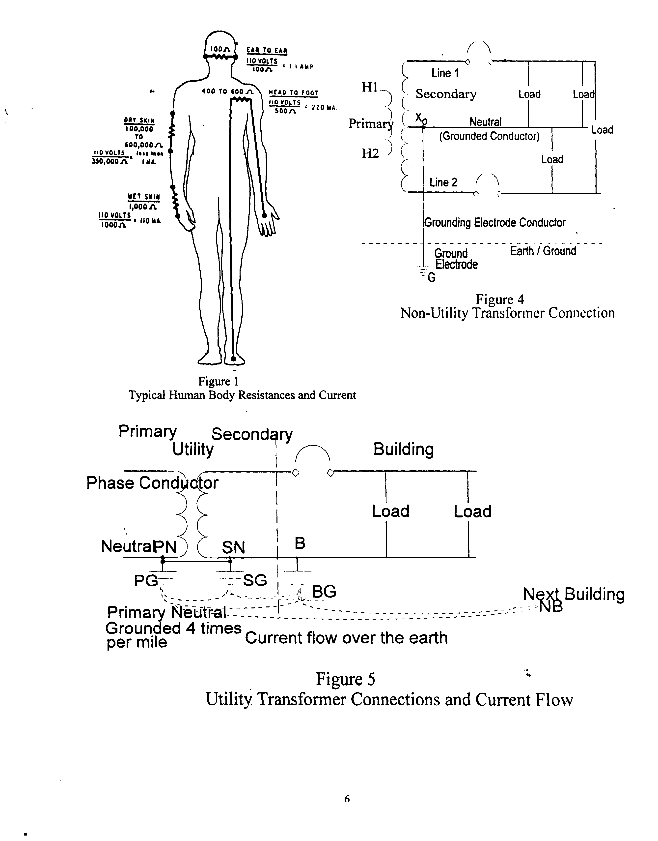

VITA

Donald W. Zipse (S'58-M'62-SM'89-F’94-LF’97) graduated from the Williamson Free School of Mechanical Trades with honors where he gained practical experience in electrical construction and in power plant operation. He received his electrical engineering degree from the University of Delaware and went to work for Cutler-Hammer as an area sales engineer. He spent 16 years with ICI America, Inc in their Central Engineering Department as a company wide electrical specialist.
For the next 14 years, he was with the FMC Corporation in their Engineering Service organization, functioning as an Electrical Engineering Consultant, responsible for providing electrical design of new facilities and consulting service to the total corporation, both chemical and mechanical groups.
He is a registered Professional Engineer. He represents the IEEE on the National Electrical Code Making Panel #14, Hazardous Locations, the Lightning Standard NFPA 780 and is a member of the International Association of Electrical Inspectors. He serves on the National Electrical Safety Code, Grounding Subcommittee.
He has served on many IEEE committees, participated in the color books, and standards groups, including the Standards Board and the Standards Board’s Review Committee. He is a member of the IEEE COMAR, Committee On Man And Radiation, and Standards Correlating Committee #28, Non-Ionization Radiation. Mr. Zipse received the Standards Medallion for his work in and promoting standards.
He has published many technical papers on such diverse and controversial subjects as Unity Plus Motors, Computers, Neutral to Ground Faults, NEC Wire Tables, Health Effects of Electrical and Magnetic Fields, Measuring Electrical and Magnetic Fields, Lightning Protection Systems: Advantages and Disadvantages, the NESC and the NEC: Are Dangerous to Your Health?, Electrical Shock Hazard Due To Stray Current and has participated on National Electrical Code panels and in teaching the Code.
For the last five years, he has been President of Zipse Electrical Engineering, Inc., a consulting firm. For the past three years, he has been primarily involved as a forensic engineer and expert witness in cases resulting from electrical accidents and electrocutions.

